**ASSIGNMENT-1**

|  |  |
| --- | --- |
| AssignmentDate | 29-10-2022 |
| StudentName | JAMEELA A |
| StudentRollNumber | 2019105017 |
| TeamID | PNT2022TMID35494 |

1. **Create registration page in html with username, email and phone number and by using POST method display it in the next html page.**

**Program:**

**App.py**

from flask import Flask,redirect,url_for,request

app=Flask(__name__)

@app.route('/success/<string:name>/<string:ml>/<string:pnm>')

def success(name,ml,pnm):

return "Welcome " + name +" !! <br><br> Your mail id is "+ml+" .<br><br> Your phone number is "+pnm

@app.route('/login',methods=['POST'])

def login():

if request.method=='POST':

user=request.form['nm']

mailid=request.form['mail']

phnum=request.form['num']

return redirect(url_for('success',name=user,ml=mailid,pnm=phnum))

if __name__=='__main__':

app.run(debug=True)

**Login.html**

<html>

<head>

<link rel="stylesheet" type="text/css" href="style.css">

<title> Welcome to the login page </title>

</head>

<body>

<form action="http://localhost:5000/login" method="POST">

<h1> <center>LOGIN FORM </center></h1>

<div class=login>

<p> Enter name :

<input type="text" name="nm"/></p>

<p> Enter mail id:

<input type="email" name="mail"/></p>

<p> Enter phone number:

<input type="number" name="num"/></p>

<p> <input type="submit" value="submit"></p>

</form>

</div>

</body>

</html>

**Style.css**

body

{

margin: 0;

padding: 0;

background-color:#6abadeba;

font-family: 'Arial';

}

.login{

width: 382px;

overflow: hidden;

margin: auto;

margin: 20 0 0 450px;

padding: 80px;

background: #D3D3D3;

border-radius: 15px ;

}

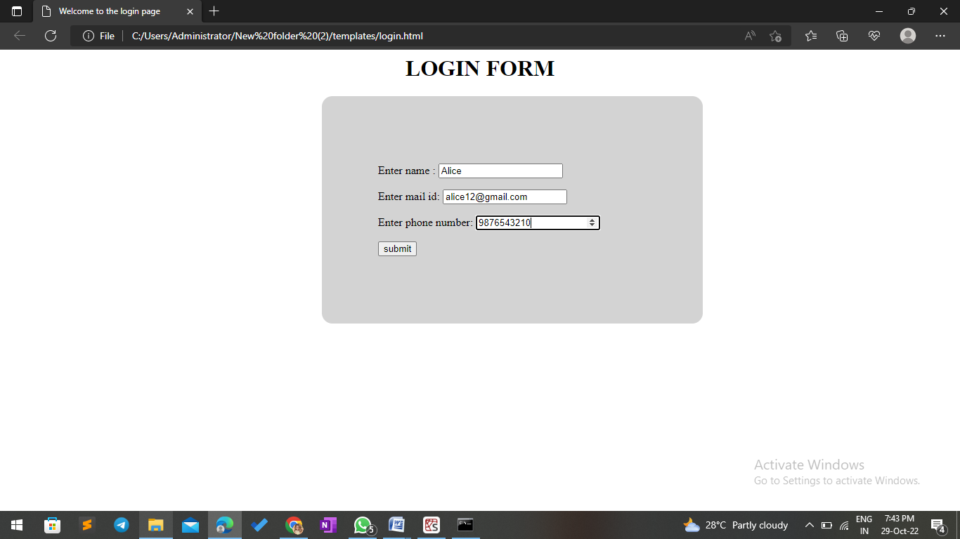

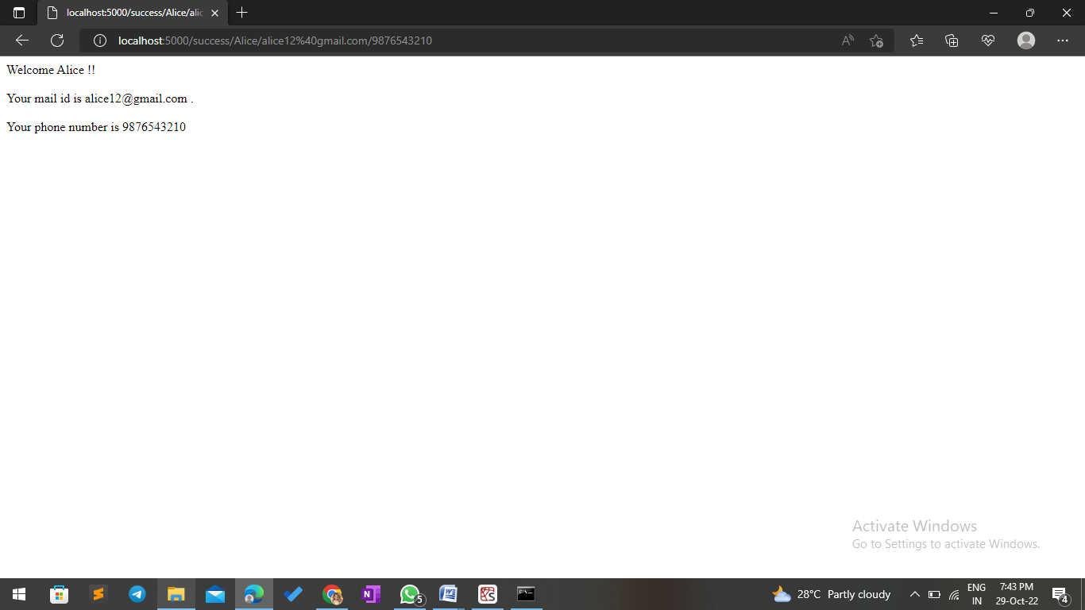

**2.Develop a flask program which should contain at least 5 packages used from pypi.org**

## base.html:

<!DOCTYPEhtml>

<html>

<head>

<title>PageTitle</title>

{%blockhead%}{% endblock%}

<linkhref="[https://cdn.jsdelivr.net/npm/bootstrap@5.2.1/dist/css/bootstrap.min.css](https://cdn.jsdelivr.net/npm/bootstrap%405.2.1/dist/css/bootstrap.min.css)"

rel="stylesheet" integrity="sha384-iYQeCzEYFbKjA/T2uDLTpkwGzCiq6soy8tYaI1GyVh/UjpbCx/TYkiZhlZB6+fzT"crossorigin="anonymous">

<scriptsrc="[https://cdn.jsdelivr.net/npm/bootstrap@5.2.1/dist/js/bootstrap.bundle.min.js](https://cdn.jsdelivr.net/npm/bootstrap%405.2.1/dist/js/bootstrap.bundle.min.js)"

integrity="sha384-u1OknCvxWvY5kfmNBILK2hRnQC3Pr17a+RTT6rIHI7NnikvbZlHgTPOOmMi466C8"crossorigin="anonymous">

</script>

</head>

<body>

<ahref="/">HOME</a>

<ahref="/Blog">BLOG</a>

<ahref="/Signin">SIGNIN</a>

<ahref="/Signup">SIGNUP</a>

<hr><br>

<divclass="container">

{%blockbody%}{%endblock%}

</div>

</body>

</html>

## blog.html:

{%extends'base.html'%}

{%blockhead%}

<title>BlogPage</title>

{%endblock%}

{%blockbody%}

<h1>ThisisSamleBlog</h1>

<h2><p>Hello,fromMr.X</p></h2>

{%endblock%}

## index.html:

{%extends'base.html'%}

{%blockhead%}

<title>HomePage</title>

{%endblock%}

{%blockbody%}

<h1>Helloeveryone,</h1>

<divclass="p-5mb-4bg-lightrounded-3">

<divclass="container-fluidpy-5">

<h1class="dispay-5fw-bold">WIFITECHNOLOGY<h1>

<pclass="col-md-8fs-4">Wi-Fiisawirelessnetworkingtechnologythatallowsdevicessuchascomputers(laptopsanddesktops),mobiledevices(smartphones

andwearables),andotherequipment(printersandvideocameras)tointerfacewith

theInternet.

</p>

</div>

</div>

{%endblock%}

## signup.html:

{%extends'base.html'%}

{%blockhead%}

<title>SignupPage</title>

{%endblock%}

{%blockbody%}

<h1>SignupPage</h1>

<formaction="Signup"method="POST">

<label>Name</label><br>

<inputtype="text"name="name"><br><br>

<label>Email</label><br>

<inputtype="email"name="email"><br><br>

<label>Phone</label><br>

<inputtype="text"name="phone"><br><br>

<label>Password</label><br>

<inputtype="password"name="name"><br><br>

<label>RetypePassword</label><br>

<inputtype="password"name="name"><br><br><br>

<inputtype="submit"class="btnbtn-primary">

</form>

{%endblock%}

## signin.html:

{%extends'base.html'%}

{%blockhead%}

<title>SigninPage</title>

{%endblock%}

{%blockbody%}

<h1>SigninPage</h1>

<formaction="/Signin"method="POST">

<label>Email</label><br>

<inputtype="email"name="email"><br><br>

<label>password</label><br>

<inputtype="password"name="name"><br><br>

<inputtype="submit"class="btnbtn-primary">

</form>

{%endblock%}

## app.py:

fromflaskimportFlask,render_templateapp=Flask(name)

@app.route('/',methods=["GET","POST"])defIndex():

returnrender_template('index.html')@app.route('/Blog')

defBlog():

returnrender_template('blog.html')@app.route('/Signup')

defSignup():

returnrender_template('signup.html')@app.route('/Signin')

defSignin():

returnrender_template('signin.html')

ifname =='main':

app.debug=Trueap.run